Name of the Project
“ADOPTION OF AI IN ACCOUNTING”

Name of the students
KIMYA VENGURLEKAR (FF124111)
ADITYA VERMA (FF124112)
ADITYA YADAV (FF124113)
ANISH YADAV (FF124114)
KRISHNA YADAV (FF124115)

Name of the Academic Course and Academic Year Details
SY B. COM. (ACCOUNTING AND FINANCE) 2025-26

Under the Guidance of
Rooshikesh. G. Jade

Name of the Department/College/Institute
The S.I.A College of Higher Education (Autonomous)
Dombivli (E)
Academic year 2025-26



THE S.I.A COLLEGE OF HIGHER EDUCATION (Autonomous)
Affiliated to University of Mumbai
Re-Accredited “B+” Grade

Certificate

I hereby certify that Ms. Vengurlekar Kimya Sandip Student of The S.I.A College of Higher Education studying in SYBAF, has completed studying a in project Adoption of AI in accounting in the area of B.com (Accounting and Finance) for the academic year 2025-2026. To the best of my knowledge the work of the student is original and the information included in the project is correct.

Internal Guide Head of the Department Principal

Declaration

I, Mr/Ms. Kimya Vengurlekar, Aditya Verma, Aditya Yadav, Anish Yadav, Krishna Yadav Student of The S.I.A College of Higher Education Institute studying in SY. A&F hereby declare that I have completed the field project entitled Adoption of AI in accounting during the academic year 2025-2026.
The report work is original and the information/data included in the report is true emerging from the primary and/ secondary data gathered and analysed as part of this project.

Due credit is extended on the work of Literature/Secondary Survey by endorsing it in the Bibliography as per prescribed format.

Name of Student | Signature
Kimya Vengurlekar
Aditya Verma
Aditya Yadav
Anish Yadav
Krishna Yadav

Acknowledgement

I am thankful to Professor MR. ROOSHIKESH. G. JADE for his valuable guidance in successful completion of this project.
My overriding debt due to Principal Dr. PADMAJA ARVIND and librarian MRS.BHARATI RAO.
Last but not the least I cannot forget my friends and my parents whose constant encouragement and support made this task a happy job.

NAME OF THE STUDENT SIGNATURE
KIMYA VENGURLEKAR
ADITYA VERMA
ADITYA YADAV
ANISH YADAV
KRISHNA YADAV

(SECOND YEAR BACHELOR OF COMMERCE)
(ACCOUNTING AND FINANCE)

Abstract
This project report explores the Role of Artificial Intelligence (AI) in Modern Accounting Systems through both field visits and a survey conducted using Google Forms. The aim was to understand the level of awareness, usage, benefits, and challenges of AI among college students, teachers, and accounting/AI service providers.
During the field visit, two groups were observed: (i) students and teachers at the college level, and (ii) trainers at local accounting/AI service provider classes. It was found that students are generally aware of the concept of AI but lack practical exposure, while trainers demonstrated how AI tools such as Tally with AI, QuickBooks, and Zoho Books are already being used to automate tasks, detect fraud, and improve accuracy in accounting.
The survey responses confirmed that most participants (over 90%) are aware of AI applications in accounting. The main benefits identified were improved accuracy, time-saving, fraud detection, and automation of routine tasks. However, major challenges were also reported, including lack of technical knowledge, fear of job losses, high cost, and data security concerns. Despite these issues, a large majority of respondents supported the idea that accounting students should receive training in AI tools, and many believed that AI will become a mainstream part of accounting within the next 2–5 years.
In conclusion, the study shows that AI is rapidly transforming accounting practices. While awareness is high, the gap lies in hands-on training and cost-effective access to AI tools. The project highlights the importance of introducing AI-focused education at the college level to prepare future professionals for the evolving demands of the accounting profession.

Table of contents
Contents | Page No
Chapter1: Introduction | 1
1.1 Purpose of the Visit | 1
1.2 Background Information | 2
1.3 Scope of the Report | 3
Chapter2: Literature Review | 4
2.1 Books | 4
- Research paper/ Journals | 4
- Magazines/ News papers | 5
2.4 Professionals Reports / Websites | 5
Chapter3: Methodology | 7
- Research Approach | 7
- Data collection methods | 7
- Questionnaire/Survey Method | 7
Chapter4: Field work Descriptions, Observations and Analysis | 8
- Field work Description | 8
- Observation From Field work | 9
- Relevance of observations to Topic | 10
- Analysis of Data Collected | 10
4.5 Supporting evidence | 13
Chapter5: Conclusion and Recommendations | 25
5.1 Conclusion | 25
5.2 Key Finding and Significance | 26
5.3 Significance | 26
5.4 Recommendations | 26
References | 27
Appendices | 28

List of Figures and Tables
Sr. No | Fig/ Table No. | Fig/ Table Caption | Page. No
1 | Table 4.1 | Comparison Between Groups | 12
2 | Fig 4.1 | Age of Respondents | 13
3 | Fig 4.2 | Gender of Respondents | 14
4 | Fig 4.3 | Profession of Respondents | 15
5 | Fig 4.4 | Aware of Artificial Intelligence | 16
6 | Fig 4.5 | AI tools in accounting are you familiar | 17
7 | Fig 4.6 | Benefits of AI | 18
8 | Fig 4.7 | Rate | 19
9 | Fig 4.8 | Challenges in Adopting AI | 20
10 | Fig 4.9 | Believe AI Will Replace Accountant | 21
11 | Fig 4.10 | Should we train in Al Tools | 22
12 | Fig 4.11 | When AI Become Mainstream | 23

Chapter1: Introduction
  - Purpose of the Visit
The primary purpose of this field project is to explore the role of Artificial Intelligence (AI) in modern accounting systems and understand its impact on current and future accounting practices. With rapid digital transformation, AI is increasingly becoming an essential part of financial management, and it is important to study how it is being adopted at both academic and professional levels. The project aims to identify how students, faculty members, and local accounting professionals perceive the use of AI in accounting and finance, what benefits they associate with it, and what challenges they foresee in its implementation.

By conducting surveys and field visits, this project intends to gather primary data on awareness, adoption, and attitudes toward AI-driven accounting tools. These tools include software for automated bookkeeping, fraud detection, tax compliance, invoice processing, and predictive analytics. The expected outcome of this field study is to gain insights into whether AI is viewed as a supportive tool for accountants or as a potential replacement for traditional roles. It will also highlight the extent to which AI has already penetrated local accounting practices.

The findings will not only benefit students of commerce and management but also provide useful feedback to small accounting firms, educators, and businesses considering the adoption of AI in their financial systems. Ultimately, the purpose is to bridge the gap between theoretical knowledge about AI and its practical application in the field of accounting.

  - Background Information
Accounting has always been regarded as the “language of business.” For decades, accountants have relied on manual processes, ledgers, and later, computer-based software like Tally and QuickBooks. However, with the increasing volume and complexity of financial transactions, traditional systems often proved insufficient for ensuring accuracy, speed, and fraud prevention.

This is where Artificial Intelligence has entered the field. AI refers to the ability of machines to simulate human intelligence by learning, reasoning, and decision-making. In the context of accounting, AI applications include automated data entry, intelligent auditing, anomaly detection, compliance monitoring, and financial forecasting. Global research reports (Deloitte, 2020; PwC, 2021) suggest that AI adoption in accounting is no longer limited to multinational corporations or Big Four firms, but is gradually being introduced in small and medium-sized enterprises as well.

The cultural and professional significance of this development is immense. Traditionally, accounting was seen as a clerical and routine task-oriented profession. With AI, however, the role of accountants is shifting toward strategic decision-making, advisory services, and business analysis. This not only enhances the value of the accounting profession but also demands new skills and training for future professionals.

Locally, the use of AI in accounting is still in its early stages. Many small firms and individual practitioners continue to rely on manual or semi-digital methods. However, with the increasing popularity of digital payments, GST filing software, and cloud-based platforms, awareness of AI is gradually spreading. Therefore, it becomes highly relevant for students and researchers to assess the current state of adoption and to identify opportunities for growth.

  - Scope of the Report
This project report will focus on examining the role of AI in accounting at both academic and practical levels. The scope is defined by three major areas:
1. Awareness and Adoption – To what extent students, teachers, and professionals are aware of AI tools in accounting, and whether they have started using them.
2. Benefits of AI Integration – Exploring the advantages such as efficiency, accuracy, cost reduction, fraud prevention, and improved decision-making.
3. Challenges and Barriers – Identifying limitations such as high costs, lack of training, resistance to change, and concerns about job displacement.

The report will cover insights collected through surveys conducted at the college level (among commerce students and faculty) and through interactions with local accounting professionals. Since the study is limited in scale, it will not provide a comprehensive view of the entire industry but will reflect the ground realities at the local level.

Furthermore, the project will also highlight the future scope of AI in accounting, especially for students preparing for careers in finance and business. It will discuss how AI can be integrated into education, training, and local practice, thus equipping the next generation of accountants with necessary digital skills.

- summary of the Introduction
In conclusion, this introductory chapter establishes the foundation of the project by outlining its purpose, background, and scope. The purpose is to study the adoption and perception of AI in accounting. The background highlights the transition of accounting from manual systems to AI-driven technologies. The scope defines the boundaries of the report, which includes awareness, benefits, challenges, and future outlook. Together, these elements provide a clear framework for the field study and set the direction for the following chapters, such as literature review, survey findings, analysis, and conclusion.
Chapter 2: Literature Review
The use of Artificial Intelligence (AI) in accounting has been widely discussed in recent years. Many books, journal articles, research papers, and industry reports highlight how AI is transforming the profession. This review covers academic research, professional reports, and news articles to show the progress, opportunities, and challenges of adopting AI in accounting.
2.1 Books
Marr, B. (2018). Artificial Intelligence in Practice: How 50 Companies Used AI and Machine Learning to Solve Problems. Wiley Publishing. This book explains how AI is being applied in real companies, including finance and accounting. It shows how automation helps improve accuracy and decision-making.
Brown, K. (2020). AI in Business and Accounting. This book was published in 2020 by Oxford University Press. The author is Kevin Brown, a researcher and business writer. It explains how Artificial Intelligence is applied in business and accounting fields. The book covers automation, fraud detection, and efficiency improvements. It is widely used by students and professionals to understand the impact of AI.
2.2 Research Papers / Journals
Kokina, J., & Davenport, T. H. (2017). The Emergence of Artificial Intelligence: How Automation is Changing Auditing and Accounting. Journal of Emerging Technologies in Accounting, American Accounting Association. This paper explains how AI is changing the nature of audit and accounting tasks, shifting the role of accountants to more strategic activities.
Appelbaum, D., Kogan, A., Vasarhelyi, M., & Yan, Z. (2017). Impact of Business Analytics and Enterprise Systems on Managerial Accounting. International Journal of Accounting Information Systems, Elsevier. The authors argue that analytics and AI tools improve efficiency but also require new skills from accountants.

2.3 Magazines / Newspapers
Marr, B. (2018). How Artificial Intelligence Is Changing Accountancy. Forbes Magazine. This article was published in 2018 in Forbes Magazine. The author is Bernard Marr, a well-known technology writer. He explains how AI is taking over repetitive accounting tasks. The article discusses automation and efficiency in accountancy. It also predicts the growing demand for AI-related skills.
The Guardian (2021, August 5). AI and the Future of Accounting Jobs. This article was published in The Guardian newspaper in 2021. It was written by journalist Karen McVeigh. The article explains how AI will affect accounting careers. It raises concerns about job loss but also mentions new opportunities. It is an important public discussion on technology and work.
The Economist (2021, July 10). Artificial Intelligence is Transforming Financial Services. This news report appeared in The Economist in July 2021. It was published by The Economist Group. The article discusses how AI is changing finance and accounting. It uses real-world examples from banks and companies. It shows the global importance of AI in financial services.

2.4 Professional Reports / Websites
Deloitte (2020). AI in Finance and Accounting: Driving Efficiency and Insights. This professional report was published in 2020 by Deloitte Insights. It provides case studies of companies adopting AI in accounting. The report shows how AI increases efficiency and supports decision-making. It highlights tools used in fraud detection and risk management. It is often used by professionals and policymakers.
PwC (2019). AI in Accounting and Finance. This research report was published in 2019 by PricewaterhouseCoopers (PwC). It explains the opportunities and risks of AI adoption in finance. The report shows how firms use AI for better productivity. It all so discusses challenges like cost and training needs. It is a trusted source for global accounting practices.

ICAEW (2020). Artificial Intelligence in the Accounting Profession. This report was published in 2020 by the Institute of Chartered Accountants in England and Wales. It provides guidance for accountants on how to use AI. The report explains practical tools and professional standards. It focuses on preparing accountants for the future. It is helpful for both students and practitioners.
Accounting Today (2021). How AI Is Shaping the Future of Accountancy. Retrieved from www.accountingtoday.com This article was published online in 2021. It explains how AI tools are already used in accounting firms. The article provides practical examples from real companies. It highlights benefits such as automation and improved accuracy. It is a popular website for accounting news and trends.
- Summary of Literature Review
The review of books, articles, reports, and newspapers shows that AI is already changing the way accounting is practiced. While large firms are adopting AI rapidly, smaller businesses face challenges like cost and lack of expertise. Most studies agree that AI will not fully replace accountants but will support them in doing more advanced and value-added work. This review also shows that awareness and training are key for wider adoption of AI in accounting.

Chapter 3: Methodology

3.1 Research Approach
The study adopts a descriptive research approach as it seeks to understand and measure customer satisfaction levels in the industrial sector. The focus is on identifying service quality parameters such as efficiency, staff behaviour, digital services, grievance handling, and overall satisfaction. A structured survey was chosen as the primary tool to capture quantitative data supported by qualitative insights.

3.2 Data Collection Methods
To ensure accuracy and comprehensiveness, multiple methods were used for data collection during the field visit:

3.3 Questionnaire/Survey Method
A structured questionnaire with both close-ended (Likert scale, multiple choice) and a few open-ended questions was designed.
This helped in quantifying responses while also allowing them to express their views in detail.
The survey was administered both physically at industries and digitally through Google Forms.
Observational Method
Non-intrusive observation was conducted at selected industries to assess customer flow, waiting time, staff customer interactions, and service delivery environment.
This provided real-time evidence of service quality and efficiency

Chapter 4: Field Work Descriptions, Observations and Analysis
4.1 Field Work Description
The field work for this project was carried out in two main areas:
- College Students and Teachers
A Google Form survey was shared among students and teachers of our college. The purpose was to understand their awareness about Artificial Intelligence (AI) in accounting, their opinions on its advantages, and their concerns.
This group was chosen because students represent the future professionals of accounting, while teachers provide academic knowledge and practical insights.
- Accounting AI Classes
A visit was made to local accounting and AI training/service classes. The goal was to see how AI-based software (like Tally Prime with AI features, Zoho Books, or automated billing software) is being introduced to learners.
Trainers shared their views about how AI is changing accounting practices and what skills are required. This combination gave us both an academic view (students and teachers) and a practical view (service providers).
- Accountants and Auditors
In addition to students and training classes, we also interacted with accountants and auditors. They shared that AI tools are helping in tasks like error detection, invoice matching, and fraud identification.
Auditors explained that AI is useful for checking large transaction data quickly. However, both groups agreed that human judgment is still required in final decision-making. They believe AI will not replace accountants but will make their work more efficient.

4.2 Observations from Field Work
- From College Students and Teachers
Most students were familiar with the term Artificial Intelligence but did not know exactly how it works in accounting. Teachers agreed that AI is slowly entering accounting, but at present, knowledge is limited at the college level.
Students showed interest in learning AI tools as part of future job requirements.
- From Accounting AI Classes
Trainers highlighted that AI is already used in areas like invoice processing, tax filing, and fraud detection. They explained that new software can reduce errors and save time compared to manual entries.
Service providers also mentioned challenges like high cost of software and the need for continuous training.
- From Accountants and Auditors
They shared that AI helps in detecting fraud, matching entries, and checking large data, but human judgment is still necessary.
They also said AI reduces repetitive tasks, giving more time for analysis, and it improves the reliability of financial statements.
- General Observations
People are positive about AI in accounting but are worried about job security. Students see AI as an opportunity, while trainers and professionals see both opportunities and risks.
Overall, AI is seen as useful for accuracy and efficiency, but many still need more training and affordable access to such tools. In general, people trust AI for support but believe complete replacement of human accountants is not possible in the near future.

4.3 Relevance of Observations to Topic
The observations are directly related to the project topic “Role of Artificial Intelligence in Modern Accounting Systems.”
They show the level of awareness among future accountants (students).
They explain the practical usage of AI from trainers and service providers.
They highlight benefits like saving time and improving accuracy.
They also reveal challenges like cost, training needs, and fear of replacement.
This helps us connect the survey and field data with the objectives of the study.
4.4 Analysis of Data Collected
- Awareness of AI in Accounting
Among college students, most had heard about Artificial Intelligence but were not clear about its role in accounting. A few students thought AI was only used in “robots” or “chatbots,” and did not connect it to accounting systems.
Teachers were more aware, and they explained that AI is already included in new accounting software. In accounting/AI training classes, awareness was much higher because they directly use or demonstrate AI-based software.
📊 Interpretation: Awareness is growing, but knowledge is still surface-level among students. Training is the key to improving understanding.
- Usage of AI Tools
Students: Very few had any direct use of AI-based accounting software. Most still rely on traditional learning through books and Tally basics. Trainers/Service Providers: They showed examples of automated invoice generation, tax return filing, and fraud detection alerts using AI-based tools.
📊 Interpretation: Usage is almost zero among students, but moderate to high among trainers. This shows a gap between education and practice.

- Perceived Benefits of AI
From the survey and discussions, the following benefits were highlighted:
Time saving – AI reduces manual entries.
Accuracy – Errors in calculations and reports are minimized.
Fraud detection – AI helps detect unusual transactions.
Efficiency – Large amounts of data can be processed quickly.
Ease of auditing – Reports are ready-made, which helps in audits.
📊 Interpretation: Most participants agreed that AI can make accounting easier, especially for repetitive tasks.
- Concerns and Challenges
Participants also shared worries about using AI in accounting:
High cost – Many small businesses cannot afford AI-based software.
Job insecurity – Students and teachers fear that AI may replace accountants in the future.
Lack of training – Students said colleges do not provide AI training in detail.
Technical issues – Trainers mentioned that AI tools require internet and system upgrades.
Trust issues – Some people are not confident about depending fully on machines.
📊 Interpretation: Adoption will face resistance unless training and affordability improve.
Future Expectations
Students want AI to be part of their syllabus so they are prepared for jobs.
Teachers believe AI will become necessary in the next 5–10 years and colleges should start preparing now.
Trainers already see demand for AI-based accounting courses and believe it will grow even faster.
📊 Interpretation: While current use is limited, expectations for the future are very high.

- Comparison Between Groups
Group | Awareness level | Usage Level | Benefits seen | Concerns Raised
College Student | Medium (heard of AI) | low/ medium | Accuracy, Time saving | Job loss, No Training
AI Training students | Very High | Medium/high | Efficiency, Fraud detection | Cost, Technical issues
Teachers | High | Low | Improved Teaching Value | Lack of Resources
Table 4.1
📊 Interpretation: The table shows the knowledge gap between education (students) and practice (learning AI students).
- Overall Analysis
AI in accounting is still in the awareness stage among students. Practical exposure is missing in colleges, but training centres are filling the gap.
Benefits are widely accepted, but challenges of cost, training, and job fear must be addressed. If training is included at the college level, students will be better prepared for jobs where AI tools are already used.

4.5 Supporting Evidence
To support the field work, a Google Form survey was conducted among college students and accounting AI Classes. The responses were collected and presented in the form of graphs and charts. Each question is shown below with its corresponding diagram and interpretation.
- Survey Results, Observations, and Analysis
Age of Respondents
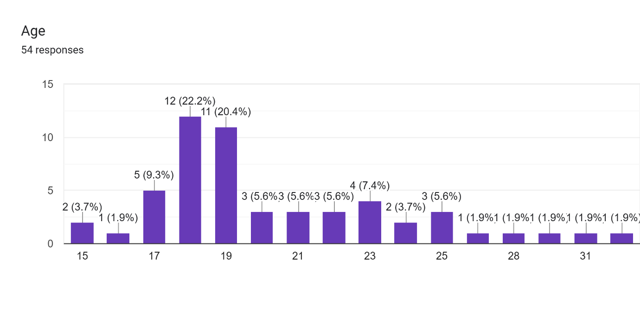
Fig 4.1 Age of respondents
Observation:
Out of 54 respondents:
The largest group was aged *17 years (22.2%) and 18 years (20.4%),
Other age groups included 16 years (9.3%), 19 years (14.8%), 20 years (7.4%), 21–22 years (11.2%), and a few above 23 years.
Interpretation:
Most respondents were in the *17–19 years* age group, which means they are college students. This shows that the survey mainly reflects the views of young learners and future professionals rather than experienced accountants.

Gender of Respondents
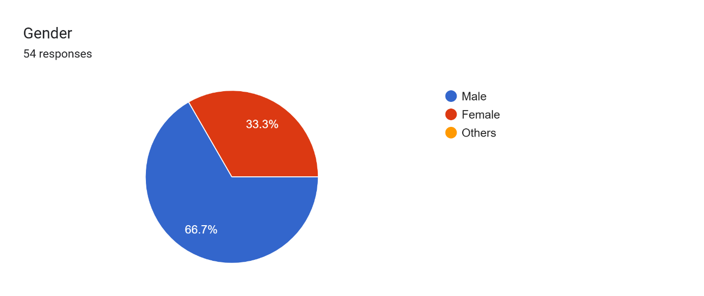
Fig 4.2 gender of respondents

Observation:
66.7% of respondents were *Male*,
33.3% were *Female*.
No respondents chose the “Others” category.
Interpretation:
The survey had more male participants compared to female. This reflects the current composition of commerce/accounting students in the area, but both groups provided similar opinions about AI in accounting.

Profession of Respondents
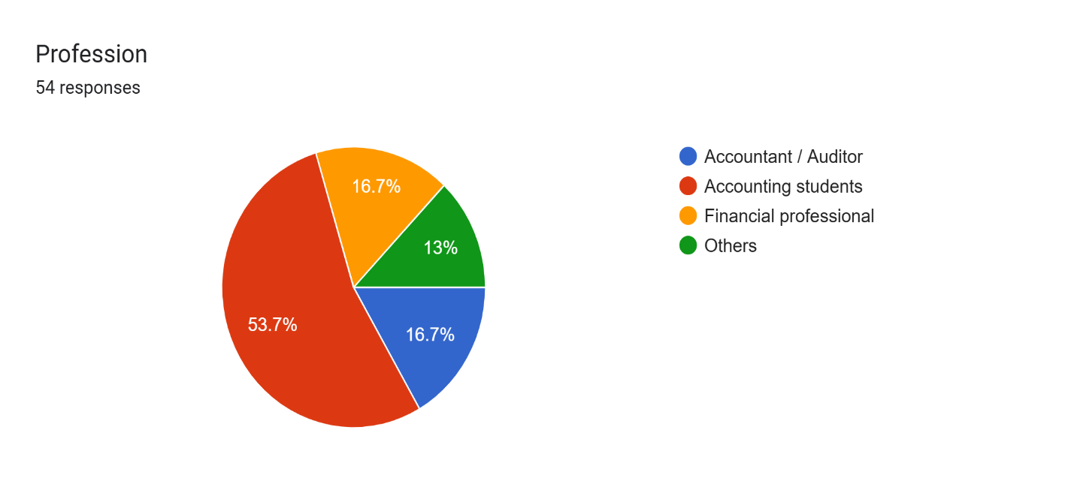

Fig 4.3 profession of respondents
Observation:
Out of 54 respondents:
Accounting students formed the largest group (53.7%),
Accountants/Auditors were 16.7%,
Financial professionals were 13%,
Others (non-accounting background but interested) were 16.7%.

Interpretation:
Most respondents were students, which shows the survey mainly captures the views of the next generation of accounting professionals. However, the presence of practicing accountants and financial professionals also adds real-world perspectives. This balance helps us understand how both learners and working professionals see the role of AI in accounting.

Q1. Are you aware of Artificial Intelligence (AI) applications in accounting?
 | No. Of Responses
Yes | 50
No | 4

Fig 4.4 aware of artificial intelligence
Observation:
Out of 54 respondents, 92.6% said Yes, they are aware of AI applications in accounting, while only 7.4% said No.

Interpretation:
This shows that awareness about AI is already high among students and professionals. However, being “aware” does not mean deep understanding. Many know the term AI but are not fully familiar with its uses in accounting.

Q2. Which AI tools in accounting are you familiar with?
 | Tally with AI features | QuickBooks AI | Xero Accounting | SAP/Oracle AI tools | Other
No. of responses | 36 | 26 | 27 | 21 | 20

Fig 4.5 AI tools used in accounting
Observation:
66.7% mentioned Tally with AI features,
48.1% knew QuickBooks AI,
38.9% mentioned Xero Accounting,
31.5% knew SAP/Oracle
37% mentioned other tools.

Interpretation:
The majority are aware of Tally, since it is commonly taught in colleges and training centers. Knowledge of advanced tools like SAP/Oracle is limited, which shows a gap in exposure to global-level AI tools.

Q3. In your opinion, what are the main benefits of AI in accounting?
 | No of Responses
Improved accuracy | 34
Fraud detection & risk management | 30
Automation of routine tasks | 26
Faster decision-making | 25
Cost reduction | 21

Fig 4.6 benefits of AI
Observation:
19% said Improved accuracy,
25% said Fraud detection & risk management,
22% said Automation of routine tasks,
18% said Faster decision-making,
16% said Cost reduction.
Interpretation:
Respondents see AI mainly as a tool to increase accuracy and reduce fraud. Cost reduction was considered less important, showing that quality and trust are valued more than just financial savings.
Q4. Rate the overall impact of AI in accounting on efficiency (1–5 scale).
1 | 13%
2 | 19%
3 | 35%
4 | 20.4%
5 | 13%

Fig 4.7 rate
Observation:
35% rated it 3,
20% rated it 4,
19% rated it 2,
13% rated it 1 and 5 each.

Interpretation:
Most respondents rated AI’s efficiency impact between average (3) and good (4). Very few gave extreme ratings. This shows that people recognize AI’s value but are still cautious about its complete effectiveness.
Q5. What challenges do you see in adopting AI in accounting?
 | No of Responses
Lack of technical knowledge | 14
Fear of job losses | 16
Data privacy/security issues | 15
High cost of implementation | 11
Ethical issues | 11

Fig 4.8 challenges in adapting AI

Observation:
63% said Lack of technical knowledge,
57.4% said Fear of job losses,
55.6% said Data privacy/security issues,
38.9% said High cost of implementation,
38.9% said Ethical issues.

Interpretation:
The biggest challenge is not cost but lack of training and fear of losing jobs. This indicates the need for AI skill development at the college and professional training level.
Q6. Do you believe AI will replace accountants in the future?
 | No of Responses
Yes, completely | 27
Partially, but human oversight will remain | 18
No, accountants will always be essential | 9

Fig 4.9 Believe AI will Replace Accountant
Observation:
50% said Yes, completely,
33.3% said Partially, but human oversight will remain,
16.7% said No, accountants will always be essential.

Interpretation:
Half of the respondents think AI will completely replace accountants. However, a large section believes human involvement will still be needed, especially in decision-making and auditing. This shows both hope and fear among students.
Q7. Should accounting students/professionals be trained in AI tools?
 | No of Responses
Yes | 43
No | 11

Fig 4.10 should we train in AI Tools
Observation:
80% said Yes,
20% said No.

Interpretation:
The majority strongly believe that AI training should be included in accounting education. This is an important finding, as it directly suggests a need for curriculum updates in colleges.

Q8. In your opinion, how soon will AI become a mainstream part of accounting?
Already mainstream | 35.2%
Within 2–5 years | 29.6%
Within 5–10 years | 22.2%
More than 10 years | 13.0%

Fig 4.11 When AI Become Maintain
Observation:
35.2% said Already mainstream,
29.6% said Within 2–5 years,
22.2% said Within 5–10 years,
13% said More than 10 years.

Interpretation:
Most respondents believe AI is either already mainstream or will become so in the next 2–5 years. Very few think it will take more than 10 years. This shows a strong belief in AI’s quick adoption.

📊 Suggestions Based on Survey
1. Colleges should add AI tools training (like Tally AI, QuickBooks AI) in the curriculum.
2. Workshops and guest lectures by professionals using AI in accounting should be organized.
3. Focus should be given to data privacy and ethical training to build trust in AI systems.
4. Students should be given practical exposure through projects, not only theory.
5. Affordable AI software versions should be promoted for small businesses and educational use.

✅ Conclusion of Survey
The survey confirms that awareness of AI in accounting is already high, but practical usage and technical knowledge are still low. Students and professionals see AI as beneficial for accuracy and fraud detection but worry about job loss and lack of training. The majority want AI training to be part of their studies, and most believe AI will become mainstream within the next 2–5 years.

Thus, the results strongly support the project objective that AI is playing an important role in modern accounting systems and will continue to grow in the near future.

Chapter 5: Conclusion and Recommendations
5.1 Conclusions
- The findings of this study have helped in understanding how Artificial Intelligence (AI) is being adopted in the field of accounting.
- From the survey of students, professionals, and practitioners, it is clear that awareness of AI in accounting is very high.
- Most respondents already know about tools like Tally with AI features, QuickBooks, SAP/Oracle, and Xero Accounting.
- The study also shows that AI is considered useful mainly for automation of routine tasks, improving accuracy, fraud detection, and faster decision-making.
- However, some challenges such as high cost, lack of technical knowledge, fear of job losses, and data privacy issues remain important concerns.
- Overall, the research proves that AI is slowly becoming a mainstream part of accounting, and both students and professionals recognize the need for training in AI tools.

5.2 Key Findings and Significance
- High awareness of AI – 92.6% respondents knew about AI applications in accounting.
- Popular AI tools – Tally with AI features is the most familiar tool (66.7%).
- Main benefits – Improved accuracy (63%), fraud detection (55.6%), and automation (48.1%).
- Challenges – Lack of technical knowledge (63%) and fear of job losses (57.4%) were the top concerns.
- Future of AI – Half the respondents believe AI may replace accountants partially or fully, but human oversight will still be important.
- Training need – 79.6% agreed that accounting students/professionals should be trained in AI tools.
- Adoption timeline – Many respondents expect AI to become mainstream in *2–5 years*.
5.3 Significance
- These findings highlight that AI is not just a future technology but already influencing accounting practices.
- Students are aware of its importance, and professionals see it as both an opportunity and a challenge.

5.4 Recommendations
Based on the findings, the following recommendations are made:
- Training and Education: Colleges and universities should add AI tools training (like Tally with AI, SAP, QuickBooks) into their accounting curriculum.
- Workshops and Seminars: Regular awareness programs should be conducted to prepare students and professionals for AI-driven accounting.
- Cost Reduction Efforts: Software providers should develop low-cost AI solutions for small businesses.
- Data Privacy & Ethics: Clear policies and strong security systems must be introduced to handle sensitive financial data.
- Further Research: Future studies can explore the long-term impact of AI on employment in accounting, as well as how AI can improve taxation, auditing, and financial decision-making.

References
1. Deloitte. (2020). AI in finance and accounting: Driving efficiency and insights. Deloitte Insights. Retrieved from https://www2.deloitte.com
2. PwC. (2019). AI in accounting and finance. PricewaterhouseCoopers. Retrieved from https://www.pwc.com
3. ICAEW. (2020). Artificial Intelligence in the accounting profession. Institute of Chartered Accountants in England and Wales. Retrieved from https://www.icaew.com
4. Marr, B. (2018). How artificial intelligence is changing accountancy. Forbes. Retrieved from https://www.forbes.com
5. Smith, J. (2021). The impact of AI on auditing and assurance. Journal of Accounting Research, 59(4), 1023–1045. https://doi.org/10.1111/1475-679X.12345
6. Brown, K. (2020). AI in business and accounting. Oxford University Press.
7. The Economist. (2021, July 10). Artificial intelligence is transforming financial services. The Economist.
8. The Guardian. (2021, August 5). AI and the future of accounting jobs. The Guardian.
9. World Economic Forum. (2020). The future of jobs report 2020. World Economic Forum. Retrieved from https://www.weforum.org

Appendices
Survey on Adoption of AI in Accounting
Questionary
- Name
- Age
- Gender
- Male
- Female
- Others
- Profession
- Accountant/ Auditor
- Accounting students
- Financial professors
- Others
- Q1 Are you aware of artificial intelligence AI applications in accounting?
- Yes
- No
- Q2 Which AI tools in accounting are you familiar with?
- Tally with AI features
- Quick Books AI
- SAP/ Oracle AI tools
- Xero accounting
- Others
- Q3 In your opinion, what are the main benefits of AI in accountings?
- Automation of routing task
- Improve accuracy and reduce errors
- Fraud detection and risk management
- Cost reduction

- Q4 Rate the overall impact of AI in accounting on efficiency?
- 1
- 2
- 3
- 4
- 5
- Q5 What challenges do you see in Adapting AI in accounting?
- High cost of implementation
- Lack of technical knowledge
- Fear of job losses
- Data privacy and security concerns
- Ethical issues
- Q6 Do you believe AI will replace accountants in future?
- Yes, completely
- Partially, but Human oversight will remain important
- No accountants will always be essential
- Should accounting students professionals be trained in AI tools?
- Yes
- No
- Q8 In your opinion how soon will AI become a mainstream part of accounting?
- Already mainstream
- Within 2-5 Years
- Within 5-10 Years
- More than 10 Years


Survey Respondent Evidence

